**Dietary fibers induce baseline-dependent, ecology-driven dynamics of murine gut microbiota and short-chain fatty acids**

**Abstract**

Dietary fibers are commonly used as an intervention of gut microbiota to promote the production of short-chain fatty acids (SCFA), which are important for host health. Despite the functional roles of gut bacteria key to dietary fiber responses have been catalogued, our understanding of the response dynamics and its individuality across microbiomes remain limited due to the lack of time series data and systems approaches for longitudinal data analysis. To address the challenge in a controlled setting, we continuously monitored microbiome profiles (absolute abundance) and targeted metabolomics of adult mice with distinct baseline microbiota undergoing intervention of inulin and resistant starch over four weeks. Generally, inulin stimulated stronger short-term responses than resistant starch and shifted both gut microbiota composition and SCFA concentration into new steady states after transient overshoot behavior, which can be explained by initial rapid growth of several inulin responders (e.g., Bacteroides acidifaciens and unclassified Muribaculaceae) and their competitions near carrying capacity. However, the dynamical responses of ~10% bacterial species and the majority of SCFAs exhibited quantitative or even qualitative baseline-dependency after treatments of both fibers. In accordance with previous studies in humans, the strong baseline-dependency poses a great challenge when extrapolating prediction of SCFA concentration from gut microbiota to unobserved baseline composition. This work reveals time- and baseline-dependency of dietary fiber responses as major challenges for personalized nutritional therapies and the necessity to search for predictive microbiota variables other than composition.

**Introduction**

Hundreds of trillions of microbes residing in the human gastrointestinal tract have a profound impact on modulating host health and physiology [1]. Disruptions in the delicate dynamic balance of gut microbiome are associated with numerous disease states. For instance, deficiency in the production of short-chain fatty acid (SCFA) has been not only associated with the occurrence of type 2 diabetes mellitus, obesity and inflammatory bowel disorders [2], but also affect the treatment of these diseases [3]. Although the mature microbiota is fairly resilient, it can be altered within individuals by both internal and external stimuli [4]. This plasticity of gut microbiome creates a distinct opportunity; by manipulating various external factors, the potential exists to reshape the architecture and biological outputs of gut microbes for improved human health [5]. Accordingly, there is intense interest in targeting the structure and metabolism of gut microbiome to promote overall health and to abrogate disease [6]. Of these, diet is the key determinant of the microbiota configuration, through modulation of the abundance of specific species and their individual or collective functions [7]. Accumulating studies associating dietary regimens, gut microbiota changes and host health led to a plethora of interventions aimed at promoting a ‘healthy microbiota’ and pursuing a ‘healthy diet’ [5].

Dietary fiber has been promoted as part of a healthy diet worldwide. The use of dietary fiber supplementation (such as inulin and resistant starches), which could provide optimal substrate to beneficial commensal microbes and thereafter promote the production of SCFAs, has shown promise in treating several disease conditions [8, 9]. However, from the microbial ecological angle, from degradation of dietary fibers to SCFA production in the gut can be a complex process mediated by many different microbes that can interact synergistically over time [10]. Primary degraders perform the initial depolymerization of polysaccharides and produce mono-, di-, and oligosaccharides, which can be utilized by another bacterial species grows and thereafter ferment to acidic end products such as lactate or SCFAs [10, 11]. These cross-feeding interactions could be directly captured by the longitudinal cascading alteration profiles of gut microbiome in response to dietary fibers, such as delayed succession of bacterial blooms of secondary degraders compared to primary degraders [12].

Over the past decade, interaction between diet and gut microbiome has been extensively studied [4]. However, most of these studies are based on cross-sectional study design and only provides a snapshot of a highly dynamic ecosystem, regardless of the fact that the response of microbial system to dietary fiber could has time-scale characteristics [13]. As a result, how the microbiome changes in composition and metabolism with dietary fiber administration, and the consistency and temporal patterns of these responses, remains poorly understood. Moreover, the ecological mechanisms through which they affect the gut microbiome and how this leads to an alteration of host physiology remains unclear. Characterizing these dynamic responses to different compounds and across individuals, with integrated longitudinal analysis of 16S rRNA sequencing, metagenomics and metabolomics, is thus an important priority for microbiome research to further understanding of diet-induced responses. Such studies have the potential to provide predictive insights into how dietary fiber and other dietary compounds can be used to improve health or treat disease via manipulating gut microbiome.

Recently, there is emerging evidence that the changes that dietary interventions elicit in host response are person-specific, calling for personalized nutrition [14]. For instance, Valcheva et al. document heterogeneous responses in fecal butyrate concentrations upon inulin supplementation, which have been significantly associated with the alleviation in the intestinal inflammation of ulcerative colitis patients [9]. This heterogeneity has been recently proposed stems from unique microbiota signatures. Since many of the fiber degraders are specialists, attacking specific bonds in specific types of polymers [15, 16]. Only a limited number of gut bacteria may be able to degrade any given dietary fibers. Therefore, the various presence and abundance of these specific degraders among individuals prior to dietary fiber supplementation could induce personalized microbial responses and outcomes [17]. As such, to improve the clinical efficacy of dietary fiber interventions with rational design of personalized nutritional intervention regimens, it is critical to understand how members of the gut ecosystem respond as individual strains as well as how they interact with one another as functional groups through longitudinal cascading alteration profiles of gut microbiome.

In the present study, using mice that harboring different gut microbiome as model hosts, we assess the dynamic response of the gut ecosystem to dietary fiber intervention by integrating longitudinal data from the gut microbiome and SCFA metabolome. We observed a universal transition between phase-specific response of the microbial metabolism in response to dietary fiber intervention, which was independent of the pretreatment microbial configuration. Through dynamic modeling analysis, we successfully identified a consortium of primary degraders that play a critical role in the breakdown of inulin, absence of which could lead to distinct subsequent SCFA production.

**Main text figures:**

***Probing the temporal behaviors of gut microbiome in response to dietary fiber***

We aimed to dissect the microbial dynamic responses to the dietary fiber intervention, which has shown promise in optimizing gut microbiome structure to treat several disease conditions. To this end, the shifts of composition and SCFAs metabolism of gut microbiome C57BL/6J mice before and after starting either cellulose (control) or inulin/resistant starch (high fiber) feeding were longitudinal monitored (**Fig 1A**). Cellulose was used as a negative control due to its low fermentability and consequent low SCFA production. Inulin is a well-documented microbiota assessable carbohydrate characterized by selectively promoting the growth of beneficial microorganisms and SCFA production [18]. With a different chemical structure from inulin that is resistant to hydrolysis by human enzymes, resistant starch escapes digestion by host small intestinal glucoamylases and transits the colon, where it is degraded by the gut microbiota and generates short-chain fatty acids (SCFAs) [19]. Multiple measurement types of the gut microbiome from longitudinal stool specimens of each mice were generated (**Fig 1A**). The temporal variations in community structure were accessed using 16S rRNA gene sequencing. Since model construction is aided by absolute abundance information, the coupling total biomass was monitored using qPCR. In addition, a paralleling targeted metabonomic approach was used to determine the dynamics of SCFAs concentrations. Through metagenomic sequencing, functional shift of the gut microbiome (e.g. gene abundance of inulinase) was documented. To understand how members of the gut ecosystem respond as individual strains as well as how they interact with one another as functional groups and thereafter promote the SCFA production when exposed to inulin and resistant starch, multiple methods were employed to dissect the metabolic process of inulin from degradation to SCFA production (**Fig 1B**).

To mirroring the response of personalized gut microbial system in humans while controlling confounding variation between individuals that driven by environmental differences and other host differences, age- and gender-matched isogenic mice for different gut microbiome were purchased from four different commercial vendors. As expected, we observed significant differences in the microbiota composition of mice purchased from the four independent breeder sources, despite being housed in the same environment and fed the same cellulose-based diet 7 days prior to analysis (**Fig 1C**). Beta diversity, which illustrates differences in taxonomic diversity between different vendors were examined using recently developed tools that are robust for investigating compositional data: DEICODE [20]. Here, Aitchison PCoA further confirmed a different distribution between different vendor-purchased mice (ANOSIM, *p* < 0.05, **Fig 1D**), with a more different gut microbial structure of Shanghai mice from other three vendors stood out. Moreover, by overlaying biplots corresponding to the taxa that represent the most significant source of variation, we were able to explore the taxonomic factors driving clustering. Specifically, for the bedrail, we observed that Shanghai mice were outlying due to the absence of several commensal microbes including *Muribaculaceae* and *Helicobacter ganmani*.

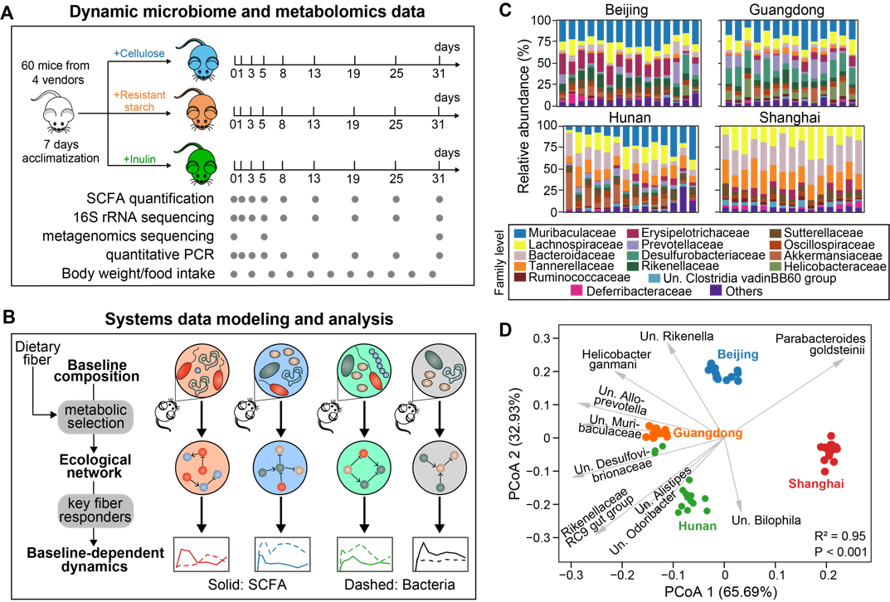

**Figure 1.** **Experimental design and computational framework for this study. A.** Schematics of the experiments performed on a mouse model. Gray dots indicate the days on which longitudinal fecal samples, microbiome and metabolomics data were collected. SCFA: short-chain fatty acid. **B.** An ecology-centric view of baseline-dependent dynamical fiber responses. We used mathematical modeling to infer ecological network under diet selection and key fiber responders that determine baseline dependency of both microbiome and SCFA dynamics. **C.** Baseline gut microbiota composition of isogenic mice purchased from four different vendors, labelled as Beijing, Guangdong, Hunan and Shanghai. **D.** PCoA (principal coordinate analysis) plot of the baseline microbiota composition. Dots represent baseline samples and gray arrows represent dominant bacterial species in the samples. The sample whose dot projects furthest in the direction of a species has the highest relative abundance of that species. R2 and P-value were obtained from Adonis analysis, which tests for baseline differences across the four vendors. For panels C, D, taxonomic labels w/ “Un.” group bacteria that are unclassified or uncultured at lower taxonomic ranks.

***Dynamical responses of short-chain fatty acid (SCFA) metabolism and murine gut microbiome to dietary fiber intervention***

Inulin feeding led to similar or slightly higher body weight compared to the cellulose group (**Supplementary Fig 1A**). Although the inulin-based diet had a significant effect (*P* < 0.01) on the food intake in three vendors, extremely small differences (less than 1g/cage*day) indicated that the effect is negligible (**Supplementary Fig 1B-C**). However, the 48-h fecal output was significantly decreased in the inulin group than in the cellulose groups (**Supplementary Fig 1D**). In line with the decreased fecal output, samples from inulin-fed mice consistently exhibited higher fecal bacterial density, signaling a longer colonic transit time that available for colonic microbial fermentation of dietary substrate in inulin groups (**Supplementary Fig 1**).

When comparing inulin to the resistant starch group, remarkably mild responses were observed to the latter dietary intervention in terms of the microbial composition and SCFA metabolism changes (**Fig 2, S2**). Most prominently, regardless of the different baseline structure, a consistent biphasic response after inulin intervention was observed among vendors in the SCFA production: after initial elevates, the total SCFA returned to but higher than its original baseline state for the remainder of the intervention, despite mice maintaining their diet for the entire study (**Fig 2A**). The magnitudes and rate of the responses of individual SCFAs were, however, vendor-specific. The most pronounced responses of individual SCFAs to inulin treatment were observed in mice from Guangdong; in contrast, mice from Beijing and Hunan showed mild increase in acetate and butyrate, whereas mice from Shanghai showed gradually increase in propionate (**Fig 2A, S2**). Taking the inulin group as an example, we performed metagenomic sequencing at day 5 and 31 to gain insights into the functional shifts that may support for the biphasic response observation. The PCoA analysis of gene family abundance showed that samples from three timepoints clustered distinctly from each other for three vendors, demonstrating a significant shift from day 5 to 31 that may mirror the functional transition from short-term response to long-term adaptation (**Fig 2C**).

To provide more comprehensive view on the response of gut microbiota to inulin intervention, we tracked the 16S rRNA gene microbiota compositions of mice after inulin/RS intervention. Shannon index (a most commonly reported diversity measure that takes into account both richness and evenness) was employed for analyzing the effect of inulin intake on the alpha diversity of the gut microbiota. Results depicted a similar biphasic dynamic pattern among four vendors (**Fig. 2B**), wherein inulin appears to cause an initial decrease in the Shannon diversity, and thereafter returned near its original baseline state for the remainder of the intervention. The magnitudes of these responses were different among vendors, with the initial decrease were considerably slight in Shanghai than in the other three vendors (**Fig. 2B**). A consistent dynamic in Pielou’s evenness score, but not in observed ASVs, was observed, suggested that this decrease in alpha diversity might be driven by an expansion of inulin-favored microbes (**Fig. S3**).

For additional insight into the biphasic response, we plotted the abundance of the observed taxa at genus level for each vendor over time (**Fig. 2D**). As expected, for both inulin and RS intervention, we observed changes within the first 5 days relative to baseline; however, these changes were not sustained throughout the remainder of the experiment. For instance, the *Bacteroidales* increased from day 0 to day 1 but decreased thereafter in inulin mice from Beijing, Guangdong and Hunan. Family *Muribaculaceae* increased from day 0 to day 3 in inulin mice from Beijing and Guangdong, whereas decreased from day 20 to day 31 in inulin mice from Guangdong. Apart from the consistent responses among vendors, several gut microbes showed different shifts between vendors as well. For instance, the increase of family *Muribaculaceae* in initial days was only observed for inulin group from Beijing and Guangdong, which showed a time-delayed trend and started from day 19 for Shanghai instead. Bacteria *Akkermansia* of the inulin group, a genus that often observed to increase in abundance after prebiotic treatment [21], showed an enrichment from day 5 and day 19 for Hunan and Shanghai mice, respectively, but no change was seen for Beijing and Guangdong mice.

To further determine the biphasic shift of gut microbiota during the experiment, we tracked the dynamics in beta diversity. We assessed how an individual gut microbiome community differed from the baseline (day 0) over time (**Fig. 2E**). The community structure in inulin mice showed a dramatic shift in the first few days, which thereafter gradually achieved a final state of ecological homeostasis of the gut microbiota. The occurrence day of these final state was individualized, ranging from around day 5 for Beijing and Hunan, around day 25 for Guangdong, and around day 19 for Shanghai. Notably, after inulin intervention for 31 days, the final state in Guangdong seemed to return to its original initial state. In contrast, the other three vendors achieved a new state that distinct from the initial states, respectively. To access the robustness and reproduceable of these findings, we re-analyzed the raw data from a recent longitudinal study [22]. This study tracked the 16S rRNA gene microbiota compositions of mice after inulin intervention sampled from day 0 to day 14. Indeed, we found similar results in the mice: after initial shifts of response, the gut microbiome achieved a final state of ecological homeostasis of the gut microbiota (**Fig. S5**). Thus, this further validated our observation and indicated that the dynamic responses of gut microbiome to dietary fiber intervention are likely widespread and baseline-dependent. Furthermore, in accord with the notion that fermentable fibers nourish microbiota, replacing the insoluble fibre, cellulose, with inulin significantly elevated the fecal microbial density (**Fig. 2F**).

Overall, these findings, together with findings from re-analysis of the independent study data, suggest a baseline-dependent microbial dynamic response to dietary fiber intervention, which consists of initial changes in composition, function and SCFA metabolism, and long-term adaptation indicating the achievement of a final state.

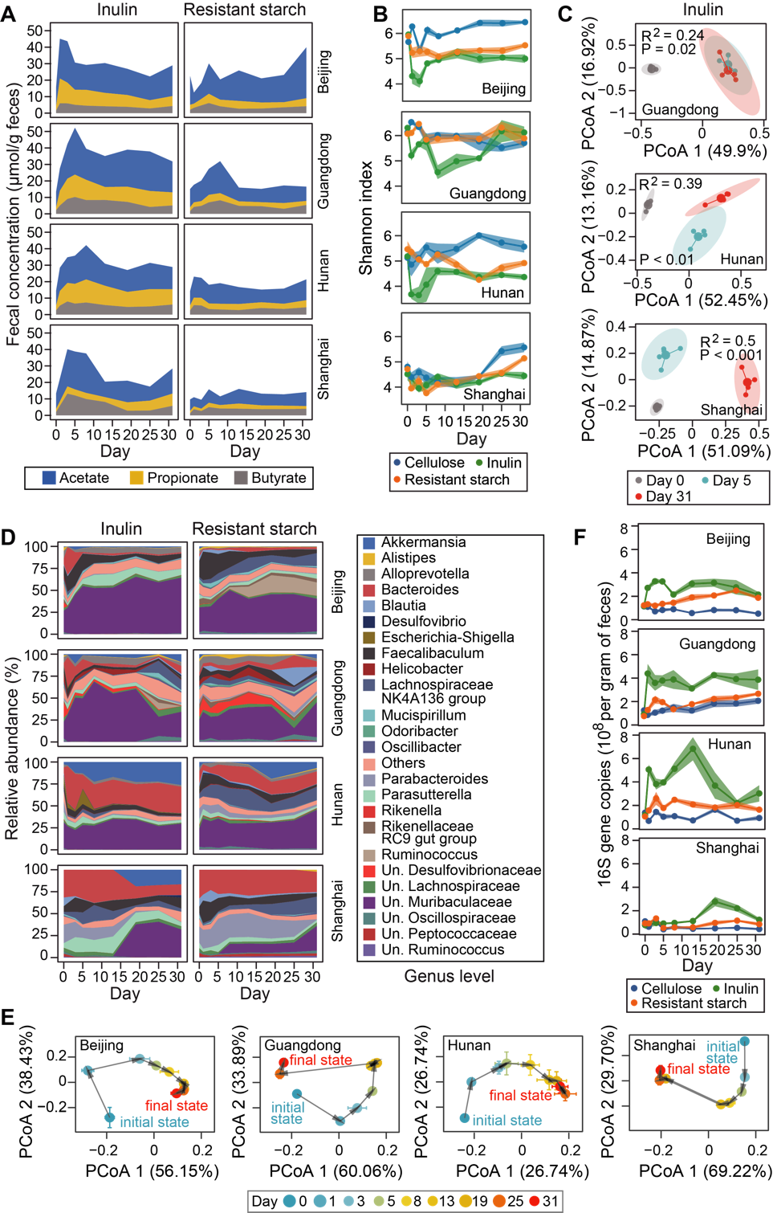

**Figure 2.** **Dynamical responses of short-chain fatty acid (SCFA) metabolism and murine gut microbiome to dietary fiber intervention. A**-**C.** Temporal changes in fecal concentration of three major SCFAs (A), microbiota alpha diversity (B), and gene abundances of mice gut metagenome (C) during four weeks’ dietary fiber intervention. Both SCFA concentration and microbiota diversity show short-term overshoot and long-term steady-state responses to inulin treatment. For panel B, taxonomic labels w/ “Un.” group bacteria that are unclassified or uncultured at lower taxonomic ranks. For panel C, R2 and P-value were obtained from Adonis analysis, which tests for the difference in gene abundances during intervention (day 0: baseline, day 5: short-term response, day 31: long-term response). **D**,**E.** The response trajectories of gut microbiota composition to inulin as well as their PCoA (principal coordinate analysis) plots (E) indicate compositional transition and convergence to a new steady state. **F**. Total bacterial density measured by quantitative PCR. **T**he heights of stacked bands (panels A, D), lines (panel B, F) or dots (panel E) represent the mean values across mice within the same vendor and shading areas (panel B, F) or error bars (panel E) represent standard error of the mean.

***Microbiota dynamics in response to inulin is driven by several key responders***

Generalized Lotka–Volterra (gLV), an ordinary differential equation model that represents microbial communities with a limited number of parameters that can be deduced from time-series data, was employed to identify candidate inulin responders, which helped us understand the individualized dynamic responses of gut microbiome from an ecological perspective.

Most of the glycan degrading and import machinery within Bacteroides genomes are encoded within clusters of coregulated genes known as polysaccharide utilization loci (PUL). The defining characteristic of a PUL is the presence of a pair of genes homologous to *susD* and *susC*, which encode outer membrane proteins that bind inulin and import its digestion products [23, 24]. Inulin PULs were also detected in draft genomes of *Bacteroides acidifaciens* and *Muribaculaceae* (**Table S4**)

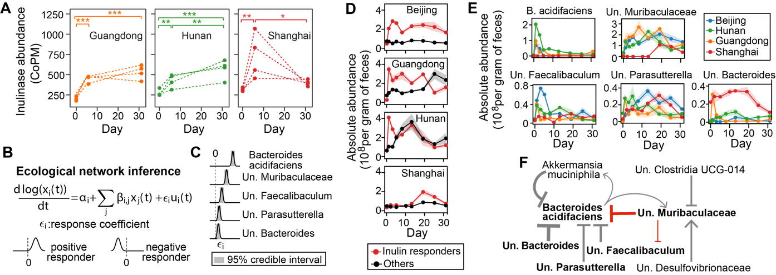

**Figure 3. Microbiota dynamics in response to inulin is driven by several key** **responders****. A.** Increased expression of inulinase genes following inulin treatment. Each dotted line represents an individual mouse. *: P < 0.05; **: P < 0.01; ***: P < 0.001. **B**. Generalized Lotka-Volterra model combined with Bayesian statistics to infer inulin responders and associated ecological interactions. **C.** Posterior distribution of five bacterial species with significant growth responses. **D**,**E**The(D) and individual (E) of five shown in panel Cfive show heterogeneous responses but eterminedynamics. **F.** Core ecological interaction network constituted by significant interspecific interactions (self-interactions not shown). Inulin responders (bold font) and key inhibitions (red arrows) are highlighted. Point and blunt arrows represent positive and negative interactions respectively. The arrow thickness is proportional to the posterior mean of the corresponding interaction coefficient. For panels C, F, significance was determined when 95% credible interval does not include 0. For panels C, E, F, taxonomic labels w/ “Un.” group bacteria that are unclassified or uncultured at lower taxonomic ranks**.**

***Visualization and quantitative significance test of baseline-dependent responses of bacterial species***

Thresholds used to define response or differentiate individuals vary based on the variables being measured and are generally not standardized .

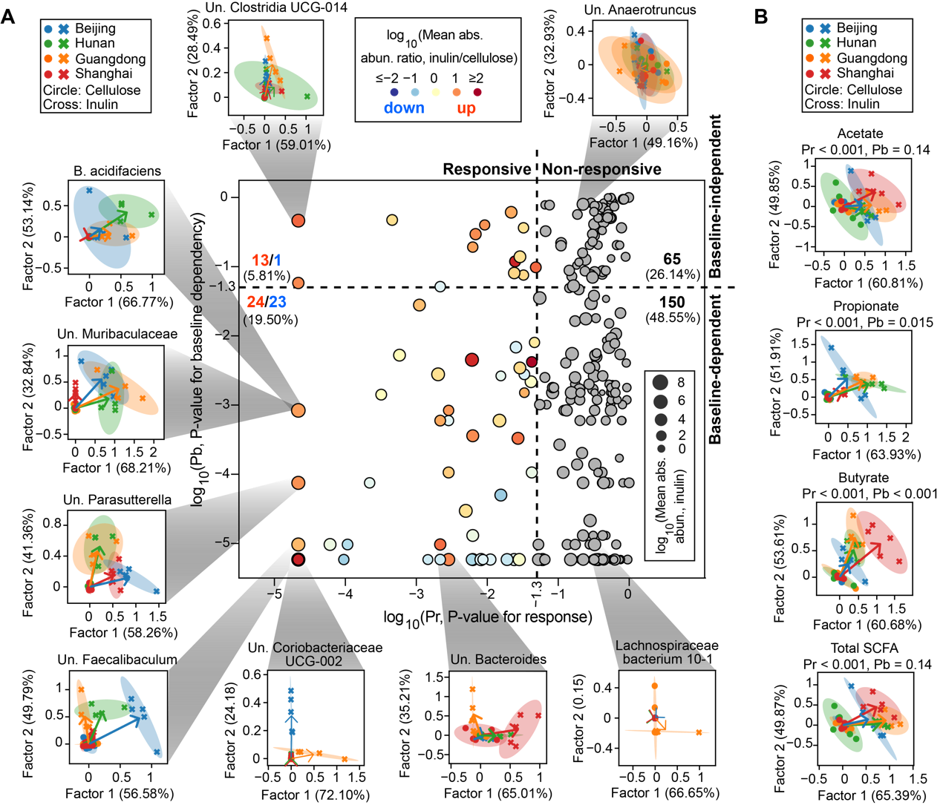

**Figure 4.** **Visualization and quantitative significance test of baseline-dependent responses of bacterial species (A) and short-chain fatty acids (SCFAs) (B) to inulin intervention.** The scatter plot in panel A distinguishes four different scenarios of baseline-dependent responses depending on the P-values for significance test of responsiveness (Pr) and baseline-dependency (Pb). The non-responsive bacterial species are marked as gray dots, while the responsive ones are colored by the ratio of their averaged absolute abundances (abs. abun.) between inulin and cellulose group. We displayed the inulin-stimulated longitudinal responses of bacterial species and SCFAs, relative to their corresponding responses in the cellulose group, in a reduced two-dimensional (2D) space spanned by factor 1 and factor 2 extracted using sequential non-negative matrix factorization (see Methods for details). In the 2D visualizations, each symbol represents a mouse (dots: cellulose group, crosses: inulin group) and all mice data from the same vendor under the same dietary fiber treatment was used to fit an eclipse. For each vendor, an arrow was drawn from the eclipse center of the vendor under cellulose treatment (standardized to the origin) to that under the inulin treatment. Numbers in parentheses on x- and y-axis labels indicate factor loadings. Taxonomic labels w/ “Un.” group bacteria that are unclassified or uncultured at lower taxonomic ranks.

***Robust learning of microbiome-metabolome relationship is challenging due to baseline-dependency***

Yin, X., et al., A Comparative Evaluation of Tools to Predict Metabolite Profiles From Microbiome Sequencing Data. Frontiers in Microbiology, 2020. 11.

Sze, M.A., et al., Fecal Short-Chain Fatty Acids Are Not Predictive of Colonic Tumor Status and Cannot Be Predicted Based on Bacterial Community Structure. mBio, 2019. 10(4): p. e01454-19.



**Figure 5.** **Robust learning of microbiome-metabolome relationship** **is** **challenging due to baseline-dependency. A**. Two data-splitting strategies for testing model performance using machine learning models. Mice in the testing sets were randomly selected on a one-per-vendor basis for “interpolation” and exclusively selected from a single vendor for “extrapolation”. **B**.Training and testing accuracy in Random Forest regression models trained on absolute abundance of bacterial species. Data in day 0 were removed from the analysis. **C**. Presence (threshold: 0.001%) and prevalence of bacterial species in baseline microbiota across mice and vendors. Species absent in any mouse baseline sample were not shown. In the bottom panel, the prevalence score of a species across mice (solid line) was defined as the fraction of mice that contains this species in their baseline microbiota and that across vendors (dashed line) was the fraction of vendors whose mice all contain this species. **D**. Receiver operating characteristic (ROC) curve analysis of the similarity between training and testing datasets. A Random Forest classifier trained to discriminate the two datasets outputs area under the ROC curve (auc) as a similarity score (see Methods for details).

**Discussion**

In the present study, we characterized the dynamical and individualized response of gut microbiota following interventions of inulin and resistant starch for 31 days. This study revealed that substantial while baseline-dependent dynamics in mice gut microbiome composition and SCFA metabolism were induced in response to inulin administration over the whole experimental period. Selective enrichments of a few critical bacterial taxa that involve in the degradation of inulin determines following changes in individual SCFA production. In contrast to inulin, resistant starch showed mild effect on gut microbiota composition and SCFA metabolism.

**Dynamical response**

Recent studies have suggested that diet is a key modifiable environmental factor which could rapidly and reproducibly alters the human gut microbiome that, in turn, could impact human physiology [14]. However, these changes only last as long as the dietary fiber is consumed [25-28]. The transient nature of these diet-induced microbial changes disappearing shortly after cessation of a dietary initiative suggest that continual intake of the nutritional substrate may be required. As such, a sustainable dietary regime is supposed could maintain the dietary effect on gut microbial composition and thereafter support the emergent of a new microbial ecology state [29]. Surprisingly, however, we found that even a prolonged dietary regime still could not sustain the alterations of SCFAs production observed in short-term intervention. There was a strong long-term adaptation of the microbial metabolism in response to inulin intervention, representing by the substantial changes in the microbial total SCFAs production that happened a few days after the start of the intervention diminished before approach a final stable state. This is in line with previous research in humans, showing that the production and concentration of SCFAs in response to treatment with fiber in patients with colonic cancer dropped down after the initial elevation before sixth week [30]. These findings suggested that this observed short-term overshoot and long-term steady-state responses is widespread and independent of the pre-treatment microbial profile.

Dietary fiber has been recently proposed could shift the microbiota to a different stable state, which may serve as a promising strategy to promote host health [31]. Here, we found that whether or not the gut microbiota could be successfully induced to a new steady state was baseline-dependent. As the published dataset [22], mice from Beijing, Hunan, and Shanghai achieved to a new stable state, while mice in Guangdong returned near its original initial state. This return trend reflects that the gut microbiome of Guangdong mice may harbor higher resilience that resilient to temporal changes by dietary fiber, meaning that homeostatic reactions restore the original community composition, as recently shown in the case of bread and other dietary regimes [32, 33].

**Responders**

Using glv model, we identified multiple inulin-responders in the complex microbiome community of the host intestine, which we believe play critical roles in the complex process of fiber degradation and metabolism.

One intriguing observation in Shanghai mice was that the abundance of identified inulin responder, *Muribaculaceae* and *B. acidifaciens*, did not increase as in other vendors until day 13, after when the gut microbiome bloom and caught up to a higher density level similar with the other vendors. Also, a gradually elevation in propionate production was observed after the enrichment of inulin responders. Together, these observations suggest that the degradation of inulin involves bacterial cross-feeding, where *Muribaculaceae* and *B. acidifaciens* are critical microbes that responsible for the primary degradation of inulin. This suggestion was further supported by a recent study showing that *Bacteroides-acidifaciens* is a species involves in inulin’s degradation [32, 33]. The other inulin responder identified here, *Muribaculaceae*, for which the name family S24-7 was used before, was previously reported to be enriched by inulin [34, 35], and this family was versatile with respect to complex carbohydrate degradation [36]. In ecological terms, the release of oligosaccharides from inulin in the mouse colon depends on the enrichment of *Muribaculaceae* or *B. acidifaciens* within the microbial community. Various enrichment of these specific degraders among individuals after dietary fiber supplementation leads to different amounts of products of degradation that available for growth of bacteria such as SCFA producers, and consequently induce personalized microbial responses and SCFA production [17]. To further access the application of our model, we reanalyzed data from four published studies where the experimental design had repeated sampling after inulin intervention. Notably, despite of significantly different pre-intervention gut microbiota among studies, two inulin responders, *Bifidobacterium* and *Anaerostipes*, were consistently identified. Hence, consistent with a recent review that focus on the impact of inulin on human gut microbiome [37], our model further confirms the bifidogenic nature of inulin, which has been attributed to the ability of genus to efficiently take up and intracellularly degrade larger inulin. Additionally, *Anaerostipes* is a butyrate-producing genus comprising both inulin degraders [38] and species capable of cross-feeding on both monosaccharides and fermentation products resulting from primary inulin degradation by *Bifidobacterium* [12]. By contrast, another three inulin responders that previously associated with polysaccharide-degrading, *Faecalibacterium*, *Prevotella*, and *Lachnospiraceae*, were individually identified, indicating that the enrichment and responses of these three bacteria might depends on the gut microbial community structure. Collectively, coupling the working model with inulin responders identified by our method, we could provide a good explanation for the individualized responses in gut microbial structure and SCFA metabolism after the inulin intervention.

Contrast to previous study [Creswell, R., et al., High-resolution temporal profiling of the human gut microbiome reveals consistent and cascading alterations in response to dietary glycans. Genome Medicine, 2020. 12(1)], only *Anaerostipes* was identified as responder by our GLV model.

**Visualization of individualized responses**

We introduced a descending dimension method for visualizing the individualized dynamic responses of gut microbiome to dietary fiber intervention and employed the distribution-free algorithm PERMANOVA to determine the significant.

Though universal microbial dynamic responses to inulin intervention among four vendors were observed, the magnitudes and rate of these responses were, however, vendor-specific, especially for Shanghai. In contrast to the response peak of other three vendors that occurred within a week, notable delayed response peaks in both microbial structure and SCFA production were observed in Shanghai mice.

**Prediction of SCFAs**

We assumed that there was no vendor-specific productivity of microbiota, therefore the microbiome-SCFA data of four vendors were analyzed together, which might be one reason that contribute to the poor prediction result.

We note that there are several limitations that merit future research. The major one was the low pre-intervention inter-individual microbial diversity provided by employed vendors. Although mice harboring distinct gut microbiome have been obtained to conduct the experiment, limited inter-individual variations in humans has been portrayed. Nevertheless, universal microbial biphasic response to dietary fiber intervention had been identified among different gut microbiome, which was further validated by reanalyzing published mice data and supported by human studies. Another important point is that, compared with humans, laboratory mice harboring distinct gut microbial community composition [39], which may lead to different metabolic interaction network and response to internal and external stimuli [40]. Indeed, different inulin responders were identified between the mice experiment and meta-analysis of human studies. However, most of these identified inulin responders have been reported for polysaccharide-degrading capacity and even were specialists for the degradation of inulin. Extended longitudinal analysis of larger human cohorts is needed to cover the substantial inter-individual variation of gut microbiome and identify more appealing probiotic to give in combination with inulin to enhance butyrate production in a larger percentage of individuals. This would be important for understanding ecological interaction between dietary fiber and gut microbiome, as well as for improving the efficacy of dietary supplements according to an individual’s gut microbiota.

The impact of dietary fibers on the gut microbiome has been widely studied. However, rare consistent and reproducible microbial responses were yielded among these studies, and this “reproducibility crisis” has been attributed to the substantial variation in pretreatment gut microbial configuration [41]. In contrast to previous cross-sectional studies, extensive longitudinal profiling of current study enabled us to detail and capture the biphasic microbial responses within an individual over time from perspectives of microbial structure and metabolism. Through the application of glv model to these time-series microbial measures, our study provides an opportunity to identify key bacteria that contribute to the individualized microbial responses. To our knowledge, this is the first report of successful application of glv model to longitudinal microbial data after dietary intervention. This framework enables us to get rid of the severe “reproducibility crisis” caused by insufferable noise and confounding factors among cross-sectional studies, and successfully capture consistent interactions between gut microbiome and dietary fiber, which could help us understand the large variation in individual’ response to a given dietary intervention and guide precisely manipulation of the gut microbiome for optimal dietary care.

**Methods**

*Animal experiment*

Specific-pathogen-free (SPF) female C57BL/6J mice for different gut microbial composition were obtained at 6 weeks of age from Beijing (A Charles River Company, Beijing, China), Hunan (Hunan Slac Jingda Laboratory Animal Company, Ltd., Changsha, China), Guangdong (Guangdong Medical Laboratory Animal Center, Foshan, China)), Shanghai (SLAC Laboratory Animal Co., Ltd., Shanghai, China). Mice were maintained on a 12-h light/dark cycle and allowed ad libitum access to food and water throughout the experiment. After acclimatizing to the diet and housing environment for 1 week, mice from each vendor were randomly separated into three groups: cellulose group, resistant starch group, and inulin group (n = 5). Composition of all diets including the source of dietary fibers cellulose, resistant starch, and inulin are provided in supplementary table 1 (**Table S1**). Fecal pellets from each mouse were freshly collected over multiple time points: day 0 (before diet change), day 1, 3, 5, 8, 13, 19, 25, and 31 (Figure 1A). Fecal samples were snap-frozen in liquid nitrogen and stored at −80 °C until further processing. At every cage change (moving the mice to a new clean cage with fresh bedding twice in one week), body weight was individually measured, and food intake and fecal output of each cage mice during the past three days per cage were measured. This study was performed in accordance with the recommendations of the National Care and Use of Animals Guidelines (China) and approved by the Institutional Animal Care and Use Committee (IACUC) of the Shenzhen Institutes of Advanced Technology, Chinese Academy of Sciences.

*GC-MS analysis of fecal SCFA concentration*

The SCFAs were analyzed according to the previous studies with modifications [42]. For the sample extraction, 0.05 g of frozen feces were mixed with 300 µL of pure water containing caproic acid-6,6,6-d3 (CDN Isotopes, Quebec, Canada) as internal standard (IS, final concentration 20 µg/mL). After adding 1.0 mm diameter zirconia/silica beads (BioSpec, Bartlesville, OK), feces were homogenized for 20 s under 6500 rpm for three times, then incubated at 4 °C with shaking for 30 min, followed by centrifugation for 30 min at 13,000×g. Following extraction with anhydrous diethyl ether, the SCFA extract accurately transferred into a glass insert in a GC vial and capped tightly after added 5 µl of N, O-bis(trimethyl-silyl)-trifluoroacetamide and vortexed for 5 s. The mixture was kept in the GC vial and incubated at room temperature (22 °C) overnight (or over 8 h) before loading to GC/MS. The analysis of acetic, propionic and butyric acids was performed by Agilent 8890/7000D triple quadrupole GC/MS equipped with a capillary HP-5 ms capillary column (30 m × 0.25 mm × 0.25 µm film thickness) (Agilent Technologies). The analytes were quantified in the selected ion monitoring (SIM) mode using the target ion and confirmed by confirmative ions. The concentration was determined with reference to the peak side of IS.

*DNA extraction and quantification of bacterial load*

For extraction of DNA, fecal material from pellets was extracted using the QIAmp PowerFecal DNA kit (Qiagen, #12830–50) following standard manufacturer procedures. DNA samples were resuspended in Buffer C6 and quantitated using the Qubit fluorometer (ThermoFisher Scientific). To quantitatively assess bacterial load, total bacteria cell counts were determined using qPCR as described recently [43].

*Amplicon and metagenomic sequencing*

16S rRNA gene sequencing was performed as previously described with modifications [44]. Library preparation was done using a two-step PCR method. During the first step of PCR, primers *S-D-Bact-0341-b-S-17* and *S-**D-Bact-0785-a-A-21* were used to target and amplify the v3-4 region, as well as to add second-step priming sites. Dual index codes were added to each sample at the second PCR step. The PCR products were purified with Agencourt AMPure XP magnetic beads (Beckman Coulter, Brea, CA, USA) and quality controlled with TapeStation (Agilent Technologies, Santa Clara, CA, USA). The final DNA concentrations of the purified products were measured with a Qubit 2.0 fluorometer (Thermo Fisher Scientific). The purified products were pooled in equal molar concentrations, and denatured following the Illumina protocol. All sequencing was done in a single run, which was performed with a 250-cycle SP kit on the NovaSeq 6000 following the NovaSeq XP workflow (Illumina, USA). Blank controls (no sample added, processed routinely, n = 4) were included in the extraction process to control for contamination throughout processing.

Metagenomic sequencing was performed using fecal samples from the inulin diet group at day 0, 5 and 31. Extracted DNA sample was purified using silica-based columns. Metagenomics sequencing libraries were prepared with at least 2 μg of total DNA using the Nextera XT DNA sample Prep Kit (Illumina, San Diego, USA) with an equimolar pool of libraries achieved independently based on Qubit 2.0 fluorometer results combined with SYBR Green quantification (Thermo Fisher Scientific, Massachusetts, USA). The indexed libraries were sequenced with a 150-cycle S4 kit on the NovaSeq 6000 following the NovaSeq XP workflow (Illumina, USA).

*Sequence analysis*

The 16S rRNA sequencing reads were analyzed in QIIME 2-2020.2 software [45]. Demultiplexed paired-end reads were trimmed to remove primers and low-quality bases with q2-cutadapt plugin. The trimmed sequences were denoised and joined with q2-dada2 plugin. Potential reagent contaminants were identified using decontam package based on either the frequency of the ASV in the blank control or the negative correlation with DNA concentration [46]. The generated feature table was filtered to remove ASVs present in only a single sample and remaining ASVs were used to construct a rooted phylogenetic tree via q2-phylogeny. Rarefaction curve analysis of the data obtained was used to estimate the completeness of microbial communities sampling and performed using the iNEXT R package [47]. Subsequently, in order to avoid sample-to-sample bias due to variable sequencing depth (different number of reads per sample), samples were rarefied to 38,980 sequences per sample. Rarefaction analysis showed that great majority of the bacteria species diversity and richness that could be sampled was captured by our sequencing depth (**Supplementary Fig. 18**), indicated sufficient sequencing depth for majority of the analyzed samples. Estimated alpha diversity metrics, beta diversity metrics (Aitchison distance [20]) and Principle Coordinate Analysis (PCoA) using q2-diversity. Group significance between alpha and beta diversity indexes was calculated with QIIME2 plugins using the Kruskal–Wallis test and permutational multivariate analysis of variance (PERMANOVA), respectively. To assign taxonomy to the amplicon sequence variants (ASVs), the q2-feature-classifier basing on the classify-sklearn naïve Bayes taxonomy classifier was used with the SILVA (v.138) as reference database.

For metagenome analysis, raw sequencing reads were subjected to quality filtering and barcode trimming using KneadData (v0.5.4) by employing trimmomatic settings of 4-base wide sliding window, with average quality per base >20 and minimum length 90 bp. Reads mapping to the mouse genome were also removed. Kraken2 was run against genome taxonomy database (GTDB_r89_54k) with default parameters [47]. Following classification by Kraken2, Bracken was used to re-estimate bacterial abundances at taxonomic levels from species to phylum using a read length parameter of 150. Next, the filtered sequences were assembled into contigs using metaSPAdes with default settings [49]. The gene abundance was analyzed and calculated as previously described with modifications [50]. Putative genes were then predicted on contigs longer than 200 base pairs using Prodigal under metagenome mode (-p meta) [51]. A non-redundant gene catalogue was constructed with CD-HIT using the parameters “-c 0.95 –aS 0.9” [52]. The abundance of each predicted gene was evaluated by mapping reads back with KMA algorithm and then normalized with the following equation: RPM = 1M × (mapped reads/gene length)/(sum of mapped reads/gene length) [53]. For all the predicted genes, CAZymes were annotated using hmmsearch against the dbCAN2 database V9 (e value <1 × 10−10; coverage >0.3) [54]. The domain with the highest coverage was selected for sequences overlapping multiple CAZyme domains. For all samples, short genomic assemblies (<2,000 bp) that could have biased the subsequent analysis were first excluded. Genomes were then binned using VAMB [55]. The binning results were refined based on the bin quality assessment (completeness >75, and contamination <15) of different binners from CheckM [56]. Taxonomic classification of each bin was determined by GTDB-tk [57], and subjected to prediction of polysaccharide utilization loci (PULz) using pipeline PULpy [58].

*Statistical analysis*

R packages *qiime2R*, *ANCOM*, *phyloseq*, *DESeq2*, *RandomForests*, *vegan*, *cluster*, *ggpubr*, *ggtern*, *rstatix*, and *ggplot2* were used for normalization, analyses, and visualization. For normally distributed continuous variables, the mean values were examined using an unpaired Student’s t test or One-way ANOVA with Tukey’s post hoc test. The level of significance was set at *P* < 0.05. Differential CAZY genes and bacterial CAGs between time points were identified using Wilcoxon matched-pair signed-rank tests (two-tailed) followed by FDR corrections.

**Supplementary figures:**

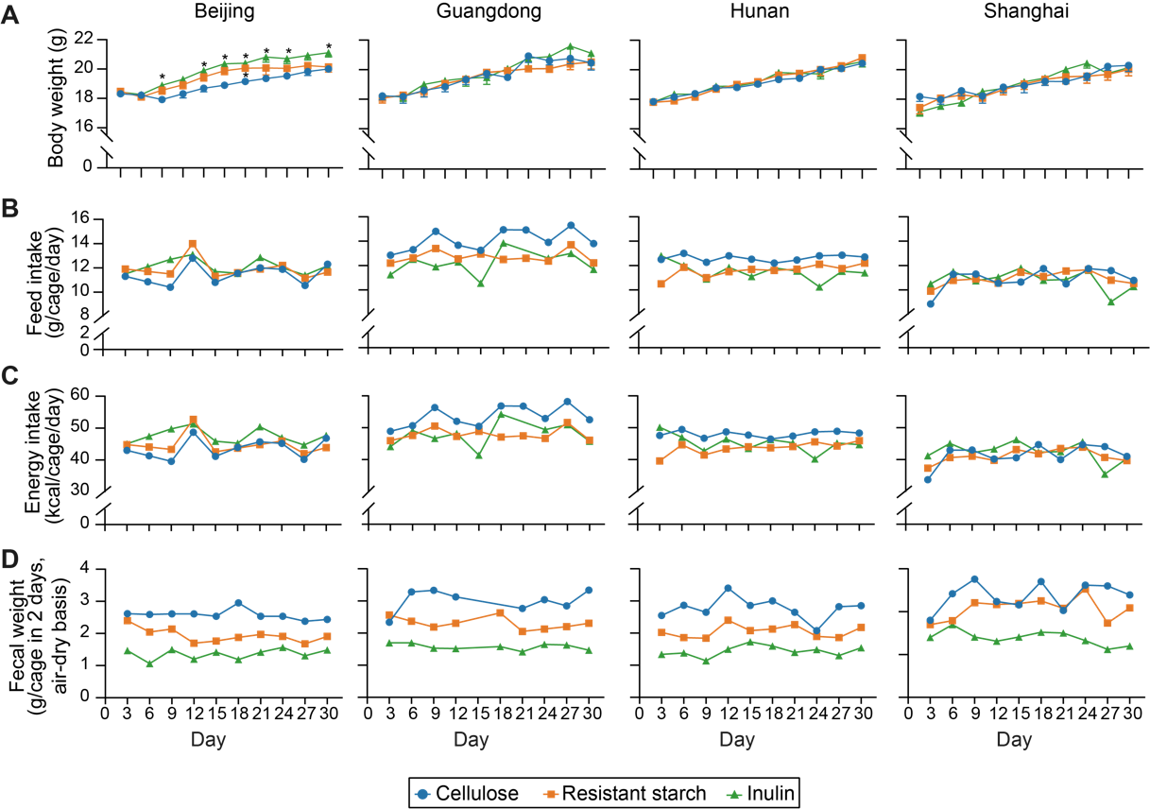

**Figure S1. (Related to Fig. 2) Effects of inulin or resistant starch on (A) body weight, (B) daily food intake, (C) daily energy intake, and (D) 48-hr fecal sample weight of mice receiving diet supplementation used in this study.** Each symbol represents the mean body weight in panel A or a single data point in panels B-D. The body weight data were analyzed by ordinary one-way ANOVA with Turkey post hoc test between inulin or resistant starch and cellulose group. *, P < 0.05.

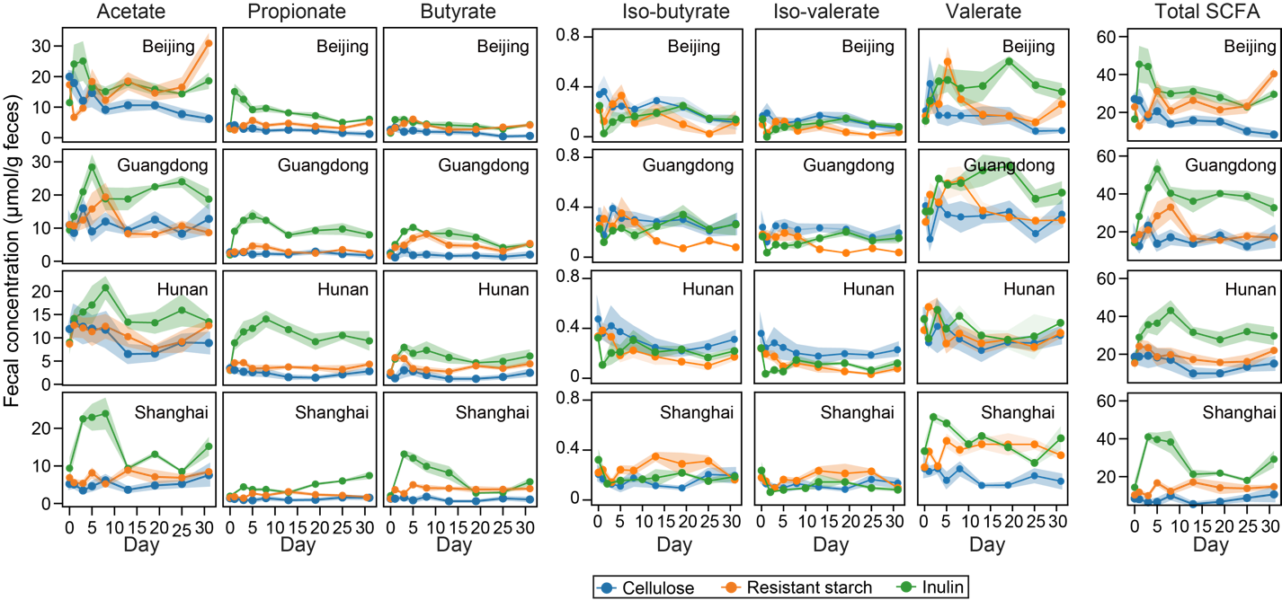

**Figure S2. (Related to Fig. 2) Dynamics of fecal short-chain fatty acid (SCFA) concentration following dietary fiber intervention.** Lines represent mean concentrations and shading areas represent standard error of the mean.

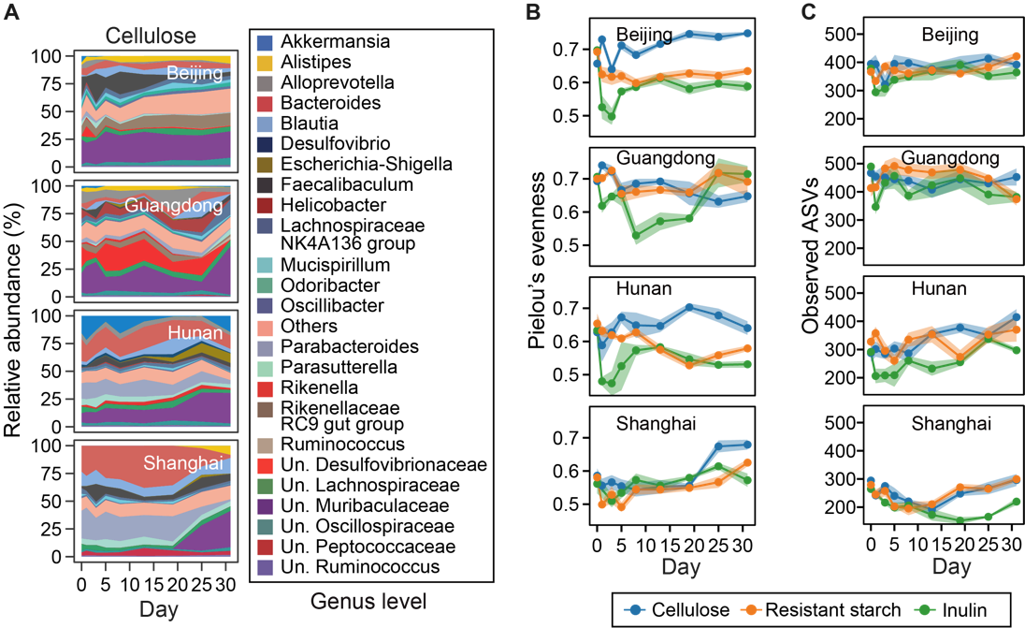

**Figure S3. (Related to Fig. 2) Dynamics of cellulose-group microbiota composition (A), evenness (B), and number of observed ASVs (C) following dietary fiber intervention.** For panel A, taxonomic labels w/ “Un.” group bacteria that are unclassified or uncultured at lower taxonomic ranks. For all panels, the heights of stacked bands (panel A) or lines (panels B, C) represent mean values across mice within the same vendor and shading areas (panels B, C) represent standard error of the mean.

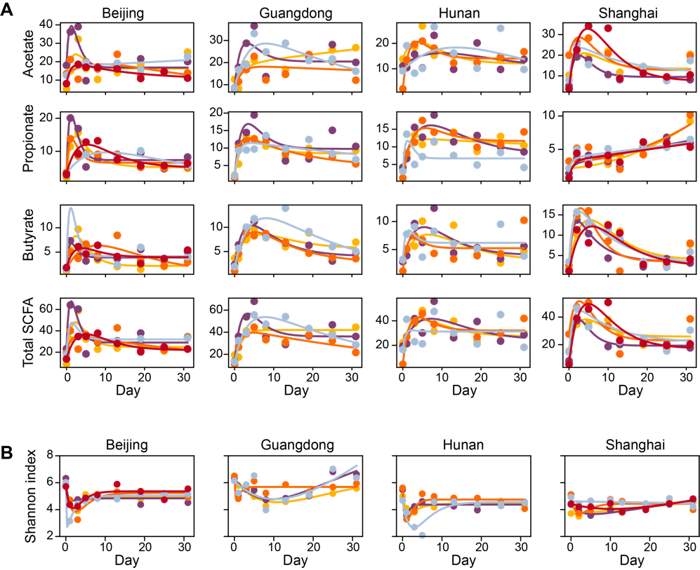

**Figure S4. (Related to Fig. 2) Fitting a harmonic oscillator model to the dynamics of short-chain fatty acids (A) and Shannon diversity (B).** Dots represent data and lines represent simulations using the best-fit parameter values. Both lines and dots are color-coded on a per-mouse basis.

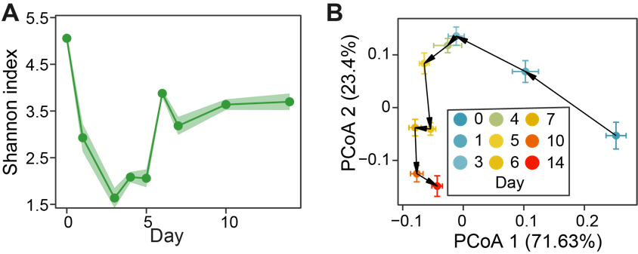

**Figure S5. (Related to Fig. 2) Reanalysis of data from Chijiwa et al., 2020, where** **a similar experiment was performed to observe the gut microbiota dynamics following inulin treatment in a mouse model.** **A**. Alpha diversity. **B**. The averaged response trajectory of gut microbiota in PCoA (principal coordinate analysis) ordination scatter plot. Each dot represents the mean principal coordinate score of all mice and the corresponding error bar represents the standard error of the mean.

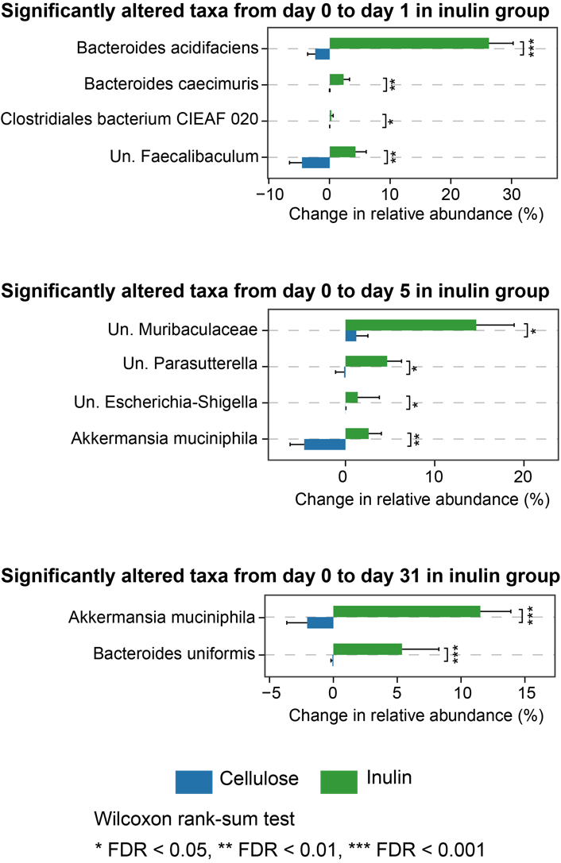

**Figure S6.** **(Related to Fig. 3) Significantly altered bacterial species in relative abundance between inulin and cellulose groups.** The identified species vary depending on the day of observation.

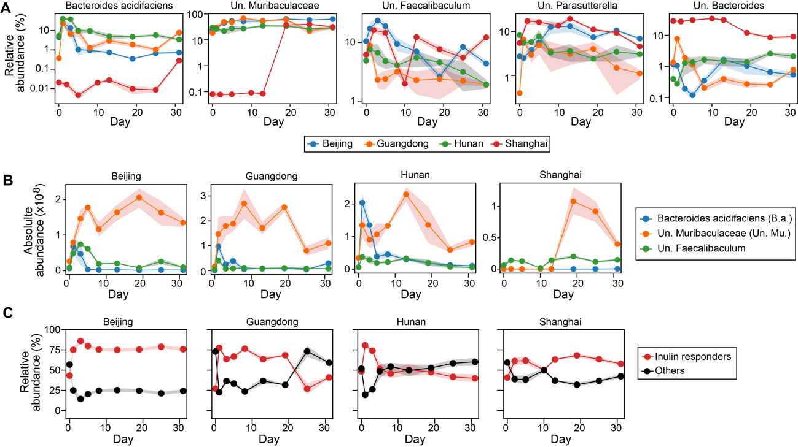

**Figure S7. (Related to Fig. 3) Dynamics of inulin responders.** **A**. Relative abundance of each inulin responder inferred from ecological network model. **B**. Three responders that might compete for inulin (see the main text Fig. 3F for inferred interspecific interactions). **C**. Comparison of total relative abundance between inulin responders and other bacterial species.

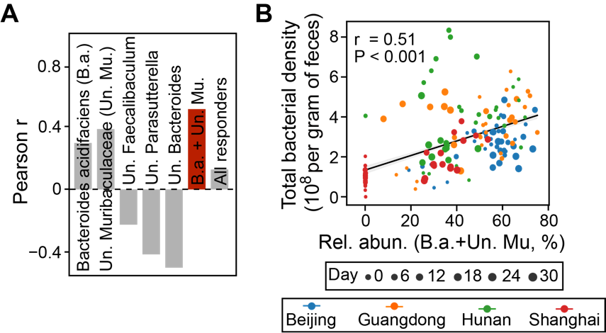

**Figure S8. (Related to Fig. 3) Prediction of total bacterial density (i.e., absolute abundance) from relative abundance of inulin responders.** **A**. Pearson correlation for different combinations of inulin responders. The red bar has the highest correlation coefficient. **B**. Scatter plot showing the positive correlation of the combined relative abundance of Bacteroides acidifaciens (B.a.) and unclassified Muribaculaceae (Un. Mu.) with total bacterial density. Gray line: linear regression (Pearson r and P-value are indicated in the plot); shading area: standard error of the regression.

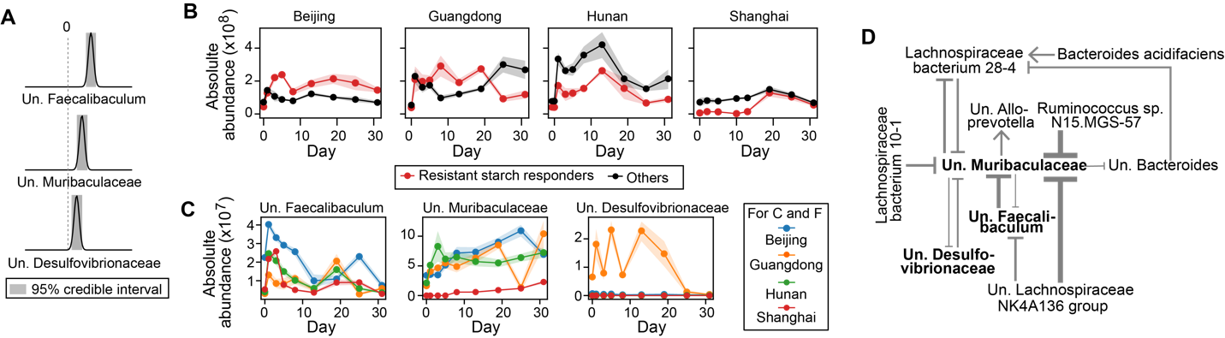

**Figure S9. (Related to Fig. 3) Inferring bacterial responders to resistant starch intervention and associated ecological interaction network.** The same figure legend applies as in the main text Fig. 3C-H (the same order).

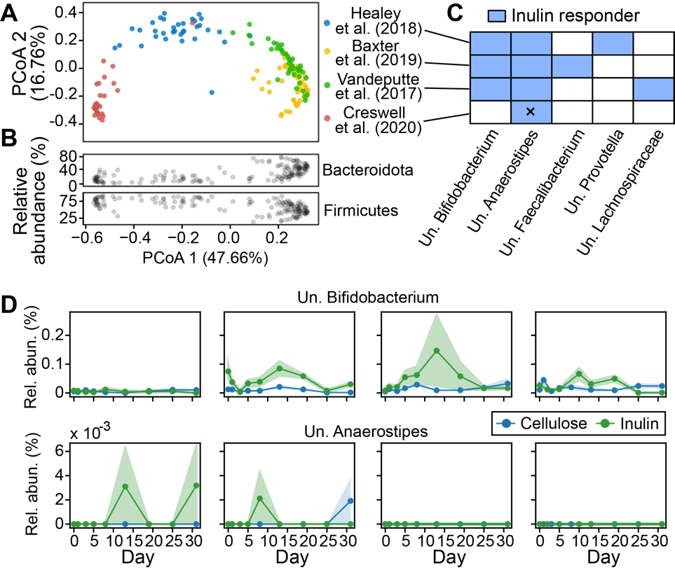

**Figure S10. (Related to Fig. 3) Inference of inulin responders in human gut microbiome. A.** Principal coordinate analysis (PCoA) of baseline human gut microbiota (Bray-Curtis distance matrix of 16S or shallow shotgun metagenomics) in four cohorts of literature studies with inulin intervention. **B.** Relative abundance of two major bacterial phyla in the same samples shown in panel A. **C.** Positive inulin responders identified from the four literature studies in panel A. We used the same generalized Lotka-Volterra model and Bayesian inference framework as we used for our mouse experiments (see Methods in the main text for details). Cross (x) represents an exception that the inferred responder (Anaerostipes hadrus) can be classified to the species level. **D**. Relative abundance (rel. abun.) of Un. Bifidobacterium and Un. Anaerostipes in the mouse gut.

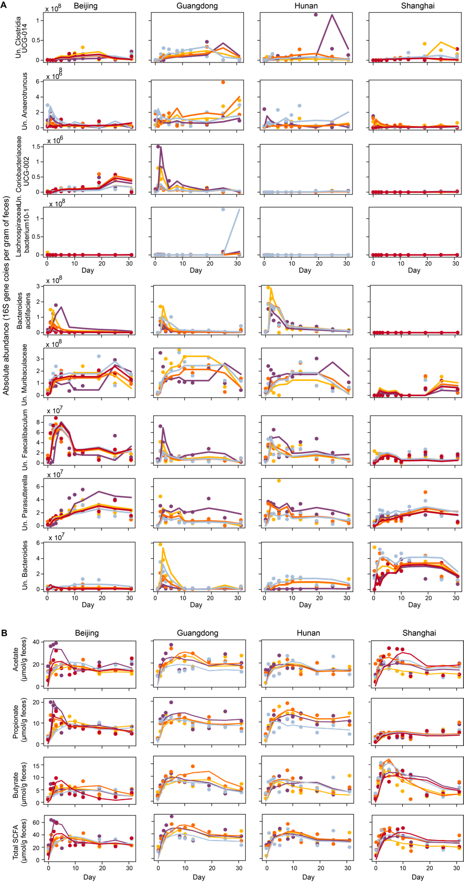

**Figure S11. (Related to Fig. 4) Reconstructed time series (lines) of selected bacterial species (A) and short-chain fatty acids (B) in the main text Fig. 4 using the first two factors of sequential Non-negative matrix factorization.** Dots represent observations and both lines and dots are color-coded on a per-mouse basis.

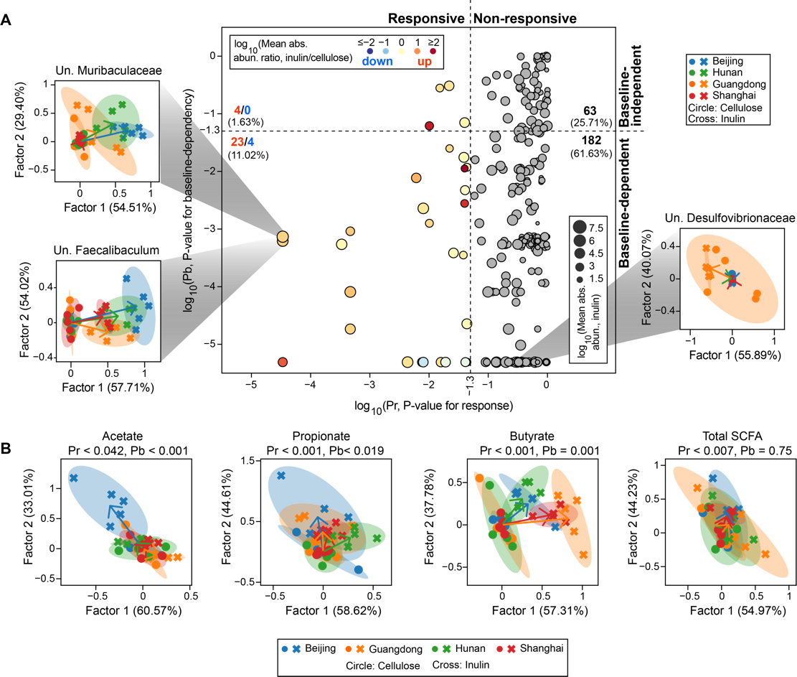

**Figure S12. (Related to Fig. 4) Individualized response analysis of bacterial species (A) and short-chain fatty acids (B) for resistant starch intervention.** The same figure legend applies as in the main text Fig. 4.

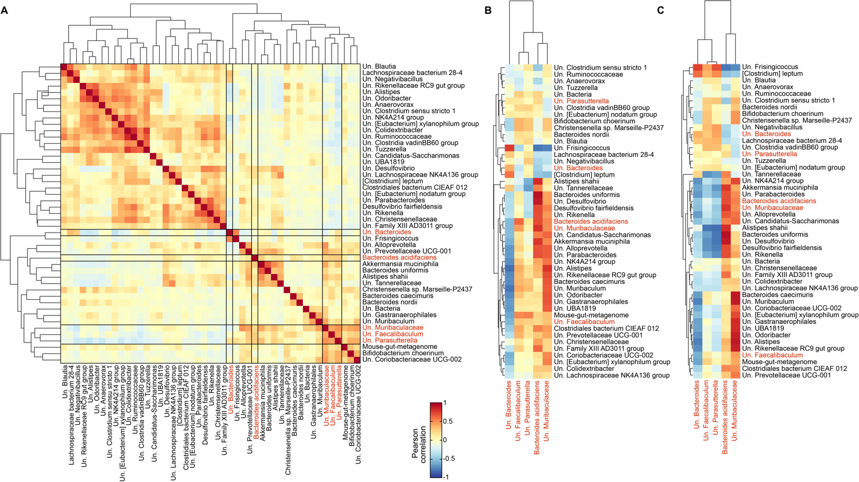

**Figure S13. (Related to Fig. 4) Pearson correlation between species w/ baseline-dependent responses (identified in the main text Fig. 4A) and inulin responders (identified in the main text Fig. 3C, highlighted in red). A**. Correlations were performed using absolute abundances at all time points. **B**,**C**. Correlations were performed using baseline absolute (B) or relative (C) abundances for species w/ baseline-dependent responses and total area under the curve of absolute abundances for inulin responders.

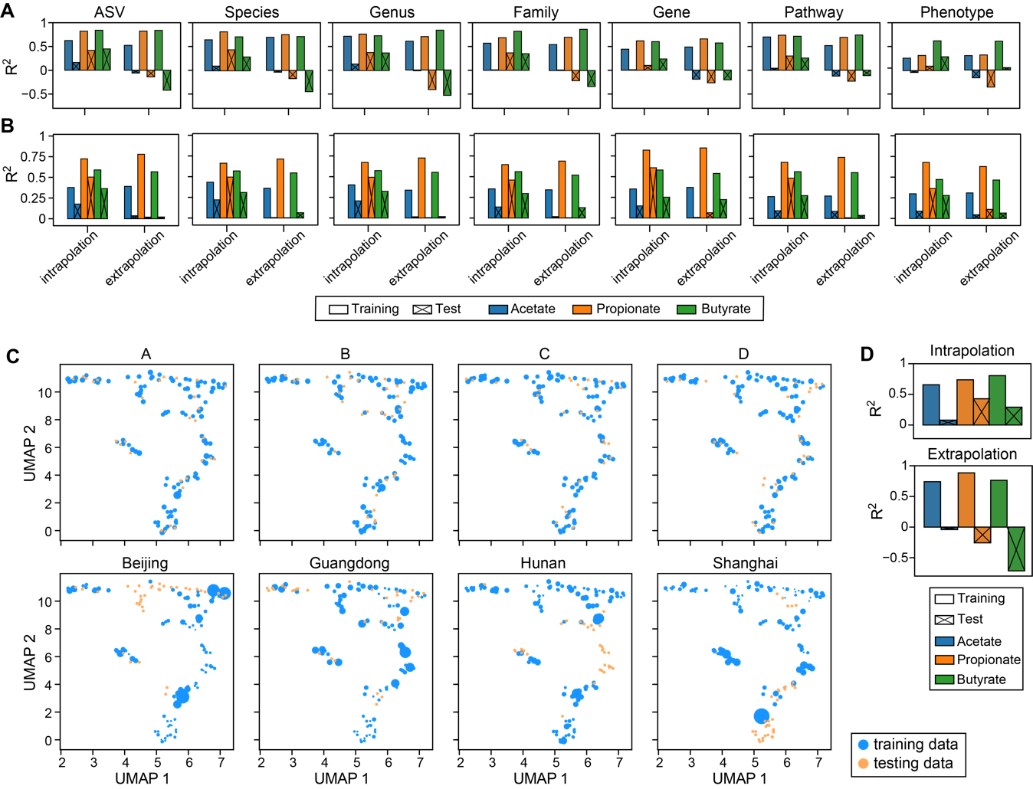

**Figure S14. (Related to Fig. 5) Poor performance of random forest model in predicting short-chain fatty acids (SCFAs) concentration (see Fig. 5B of the main text for results) cannot be rescued by using (A) alternative predictors, (B) alternative regression models, and (C,D) weighting of training samples. A**. Prediction accuracy using random forest regression model and taxonomic (ASV, Species, Genus, Family) or functional (Gene, Pathway, Phenotype) representation of gut microbiota as predictors. The abundances of genes, pathways and phenotypes were predicted using PICRUSt2. **B**. Prediction accuracy using MelonnPan and the same predictors as used in panel A. **C**. Sample weights under different data-splitting strategies. The weights of training samples closer to their corresponding test samples were assigned higher values, as indicated by larger circle sizes in a reduced two-dimensional UMAP (Uniform Manifold Approximation and Projection) space.The sample weight was calculated as 1/Pi-1, where Pi is the probability of sample i belonging to the training distribution and was estimated using random forest classifier (the same approach was applied to generate Receiver Operating Characteristics curves in Fig. 5D of the main text; see Methods in the main text for details). **D**. Prediction accuracy using random forest regression model built from weighted training data and absolute abundances of bacterial species as predictors.

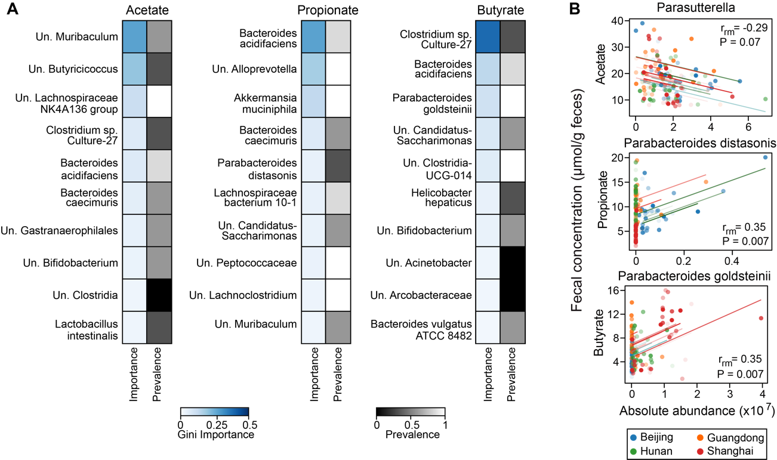

**Figure S15. Inferred short-chain fatty acid (SCFA) producers in inulin-treated mice vary depending on the inference approaches (Random forest regression vs. Repeated correlation analysis). A.** Random forest (RF) regression. For each SCFA, we showed top 10 bacterial species with the highest Gini importance score in model training using all data. The absolute abundances of bacterial species were standardized and filtered (threshold 10-5) by LASSO (least absolute shrinkage and selection operator) regression before passing to RF model. Several key hyperparameters in LASSO and RF were optimized using grid search cross-validation with R2 as the score metric. The vendor-level prevalence scores were obtained from Fig. 5C in the main text. **B**. Repeated correlation analysis. Longitudinal data and correlation trend lines are color-coded on a per-mouse basis. Repeated measures correlation coefficients (*r*rm) and FDR-corrected P-values are indicated in the plot.

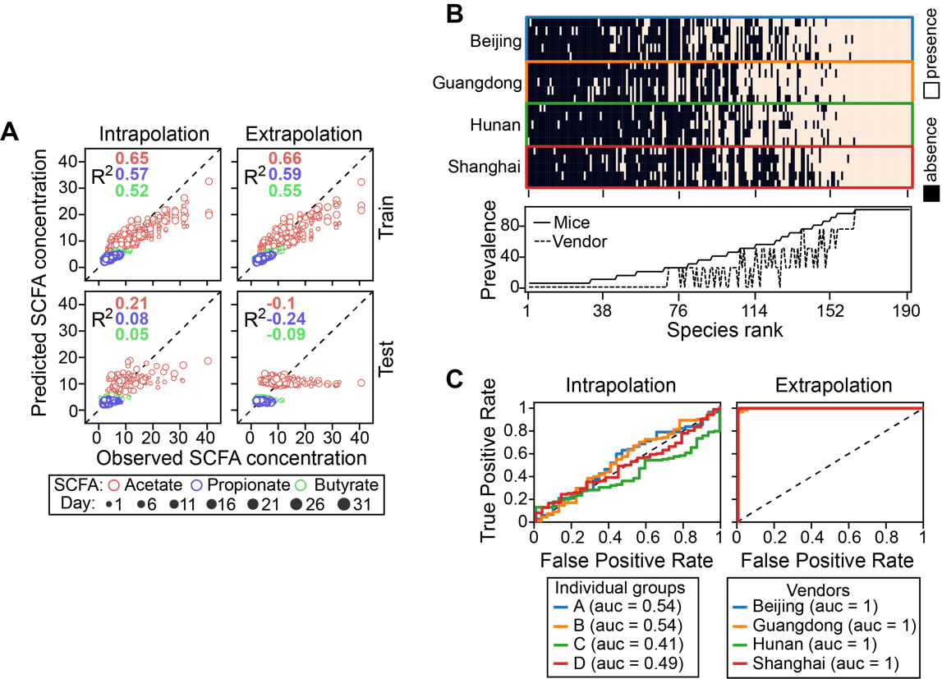

**Figure S16 (Related to Fig. 5) Prediction of short-chain fatty acid (SCFA) concentration from gut microbiota using data from resistant starch-treated mice**. The same figure legend applies as in the main text Fig. 5B-D (the same order).

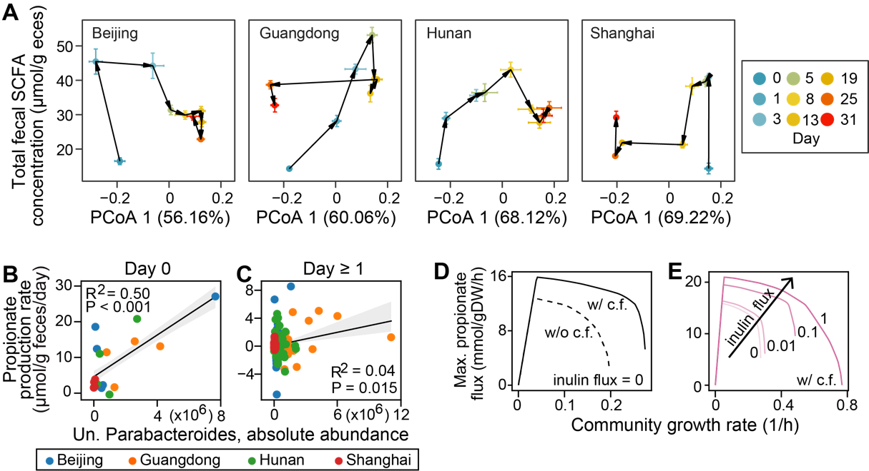

**Figure S17**. **(Related to Discussion)** The quantitative microbiome-metabolome relationship varies in a complex, time-dependent manner. **A**. Dynamics of gut microbiota composition (x-axis) and total SCFA concentration (y-axis) plotted on the same graph. We used the first principal coordinate score from PCoA (principal coordinate analysis) ordination to represent changes in gut microbiota composition (relative abundance) along the direction of maximum variance. Note that SCFA were substantially produced between day 0 and day 1, while gut microbiota composition only changes slightly. Points represent the mean PCoA scores across mice within each vendor and error bars represent the standard error of the mean. **B**-**E**. Potential producers and cross-feeding relationships for initial propionate production within a day of inulin treatment. **B**,**C**. Correlation of baseline unclassified (Un.) Parabacteroides absolute abundance with initial propionate production rates on day 0 (B) and rates in later days (C). Gray line: linear regression (R2 and P-value are indicated in the plot); shading area: standard error of the regression. **D**,**E**. Simulated effects of cross-feeding (c.f.) (D) and inulin availability (E) on growth and propionate flux of two-genera Bacteroides-Parabacteroides community. w/ c.f.: mixing Bacteroides and Parabacteroides in 1:1 ratio; w/o c.f.: mixing Parabacteroides and its clone mate in 1:1 ratio.

**8(Related to Materials and Methods)**

**References:**

[1]. Lynch, S.V. and O. Pedersen, The Human Intestinal Microbiome in Health and Disease. New England Journal of Medicine, 2016.

[2]. Sanna, S., et al., Causal relationships among the gut microbiome, short-chain fatty acids and metabolic diseases. Nature Genetics, 2019. 51(4): p. 600-605.

[3]. Nomura, M., et al., Association of Short-Chain Fatty Acids in the Gut Microbiome With Clinical Response to Treatment With Nivolumab or Pembrolizumab in Patients With Solid Cancer Tumors. JAMA Network Open, 2020. 3(4): p. e202895.

[4]. Gentile, C.L. and T.L. Weir, The gut microbiota at the intersection of diet and human health. Science, 2018. 362(6416

): p. 776

-780

.

[5]. Wargo, J.A., Modulating gut microbes. Science, 2020. 369(6509): p. 1302-1303.

[6]. Harkins, C.P., H.H. Kong and J.A. Segre, Manipulating the Human Microbiome to Manage Disease. JAMA, 2019. 323(4): p. 303.

[7]. Gehrig, J.L., et al., Effects of microbiota-directed foods in gnotobiotic animals and undernourished children. Science, 2019. 365(6449): p. eaau4732.

[8]. Zhao, L., et al., Gut bacteria selectively promoted by dietary fibers alleviate type 2 diabetes. Science, 2018. 359(6380): p. 1151-1156.

[9]. Valcheva, R., et al., Inulin-type fructans improve active ulcerative colitis associated with microbiota changes and increased short-chain fatty acids levels. Gut Microbes, 2019. 10(3): p. 334-357.

[10]. Rakoff-Nahoum, S., M.J. Coyne and L.E. Comstock, An Ecological Network of Polysaccharide Utilization among Human Intestinal Symbionts. Current Biology, 2014. 24(1): p. 40-49.

[11]. Solden, L.M., et al., Interspecies cross-feeding orchestrates carbon degradation in the rumen ecosystem. Nature Microbiology, 2018. 3(11): p. 1274-1284.

[12]. Falony, G., et al., Cross-Feeding between Bifidobacterium longum BB536 and Acetate-Converting, Butyrate-Producing Colon Bacteria during Growth on Oligofructose. Applied and Environmental Microbiology, 2006. 72(12): p. 7835-7841.

[13]. Creswell, R., et al., High-resolution temporal profiling of the human gut microbiome reveals consistent and cascading alterations in response to dietary glycans. Genome Medicine, 2020. 12(1).

[14]. Kolodziejczyk, A.A., D. Zheng and E. Elinav, Diet-microbiota interactions and personalized nutrition. Nat Rev Microbiol, 2019. 17(12): p. 742-753.

[15]. Cockburn, D.W. and N.M. Koropatkin, Polysaccharide Degradation by the Intestinal Microbiota and Its Influence on Human Health and Disease. J Mol Biol, 2016. 428(16): p. 3230-3252.

[16]. Ze, X., et al., Ruminococcus bromii is a keystone species for the degradation of resistant starch in the human colon. ISME J, 2012. 6(8): p. 1535-43.

[17]. Salonen, A., et al., Impact of diet and individual variation on intestinal microbiota composition and fermentation products in obese men. ISME J, 2014. 8(11): p. 2218-30.

[18]. Ahmed, W. and S. Rashid, Functional and therapeutic potential of inulin: A comprehensive review. Crit Rev Food Sci Nutr, 2019. 59(1): p. 1-13.

[19]. Cerqueira, F.M., et al., Starch Digestion by Gut Bacteria: Crowdsourcing for Carbs. Trends in Microbiology, 2019.

[20]. Martino, C., et al., A Novel Sparse Compositional Technique Reveals Microbial Perturbations. mSystems, 2019. 4(1).

[21]. Belzer, C., et al., Microbial Metabolic Networks at the Mucus Layer Lead to Diet-Independent Butyrate and Vitamin B12 Production by Intestinal Symbionts. mBio, 2017. 8(5).

[22]. Chijiiwa, R., et al., Single-cell genomics of uncultured bacteria reveals dietary fiber responders in the mouse gut microbiota. Microbiome, 2020. 8(1): p. 5-14

.

[23]. Rakoff-Nahoum, S., K.R. Foster and L.E. Comstock, The evolution of cooperation within the gut microbiota. Nature, 2016. 533(7602): p. 255-259.

[24]. Koropatkin, N.M., E.A. Cameron and E.C. Martens, How glycan metabolism shapes the human gut microbiota. Nat Rev Microbiol, 2012. 10(5): p. 323-35.

[25]. Baxter, N.T., et al., The Glucoamylase Inhibitor Acarbose Has a Diet-Dependent and Reversible Effect on the Murine Gut Microbiome. mSphere, 2019. 4(1).

[26]. Walker, A.W., et al., Dominant and diet-responsive groups of bacteria within the human colonic microbiota. ISME J, 2011. 5(2): p. 220-30.

[27]. David, L.A., et al., Diet rapidly and reproducibly alters the human gut microbiome. Nature, 2014. 505(7484): p. 559-63.

[28]. Hiel, S., et al., Effects of a diet based on inulin-rich vegetables on gut health and nutritional behavior in healthy humans. Am J Clin Nutr, 2019. 109(6): p. 1683-1695.

[29]. Wu, G.D., et al., Linking long-term dietary patterns with gut microbial enterotypes. Science, 2011. 334(6052): p. 105-8.

[30]. Nordgaard, I., et al., Colonic production of butyrate in patients with previous colonic cancer during long-term treatment with dietary fibre (Plantago ovata seeds). Scand J Gastroenterol, 1996. 31(10): p. 1011-20.

[31]. Dogra, S.K., J. Doré and S. Damak, Gut Microbiota Resilience: Definition, Link to Health and Strategies for Intervention. Frontiers in Microbiology, 2020. 11.

[32]. Fragiadakis, G.K., et al., Long-term dietary intervention reveals resilience of the gut microbiota despite changes in diet and weight. The American Journal of Clinical Nutrition, 2020.

[33]. Korem, T., et al., Bread Affects Clinical Parameters and Induces Gut Microbiome-Associated Personal Glycemic Responses. Cell Metab, 2017. 25(6): p. 1243-1253.e5.

[34]. Zhu, L., et al., Inulin with different degrees of polymerization modulates composition of intestinal microbiota in mice. FEMS Microbiology Letters, 2017. 364(10).

[35]. Li, L., et al., Inulin with different degrees of polymerization protects against diet-induced endotoxemia and inflammation in association with gut microbiota regulation in mice. Scientific reports, 2020. 10(1): p. 978-12.

[36]. Lagkouvardos, I., et al., Sequence and cultivation study of Muribaculaceae reveals novel species, host preference, and functional potential of this yet undescribed family. Microbiome, 2019. 7(1).

[37]. Le Bastard, Q., et al., The effects of inulin on gut microbial composition: a systematic review of evidence from human studies. European Journal of Clinical Microbiology & Infectious Diseases, 2019.

[38]. Scott, K.P., et al., Prebiotic stimulation of human colonic butyrate-producing bacteria and bifidobacteria, in vitro. FEMS Microbiol Ecol, 2014. 87(1): p. 30-40.

[39]. Hugenholtz, F. and W.M. de Vos, Mouse models for human intestinal microbiota research: a critical evaluation. Cellular and Molecular Life Sciences, 2017.

[40]. Lim, R., et al., Large-scale metabolic interaction network of the mouse and human gut microbiota. Scientific Data, 2020. 7(1).

[41]. Schloss, P.D., Identifying and Overcoming Threats to Reproducibility, Replicability, Robustness, and Generalizability in Microbiome Research. mBio, 2018. 9(3).

[42]. Zhang, S., H. Wang and M. Zhu, A sensitive GC/MS detection method for analyzing microbial metabolites short chain fatty acids in fecal and serum samples. Talanta, 2019. 196: p. 249-254.

[43]. Jian, C., et al., Quantitative PCR provides a simple and accessible method for quantitative microbiota profiling. PLOS ONE, 2020. 15(1): p. e0227285.

[44]. Gohl, D.M., et al., Systematic improvement of amplicon marker gene methods for increased accuracy in microbiome studies. Nature Biotechnology, 2016. 34(9): p. 942-949.

[45]. Bolyen, E., et al., Reproducible, interactive, scalable and extensible microbiome data science using QIIME 2. Nat Biotechnol, 2019. 37(8): p. 852-857.

[46]. Davis, N.M., et al., Simple statistical identification and removal of contaminant sequences in marker-gene and metagenomics data. Microbiome, 2018. 6(1).

[47]. Hsieh, T.C., K.H. Ma and A. Chao, iNEXT: an R package for rarefaction and extrapolation of species diversity (H ill numbers). Methods in Ecology and Evolution, 2016. 7(12): p. 1451-1456.

[48]. Wood, D.E., J. Lu and B. Langmead, Improved metagenomic analysis with Kraken 2. Genome Biology, 2019. 20(1).

[49]. Nurk, S., et al., metaSPAdes: a new versatile metagenomic assembler. Genome Res, 2017. 27(5): p. 824-834.

[50]. Zhao, Z., F. Baltar and G.J. Herndl, Linking extracellular enzymes to phylogeny indicates a predominantly particle-associated lifestyle of deep-sea prokaryotes. Science advances, 2020. 6(16): p. eaaz4354.

[51]. Hyatt, D., et al., Prodigal: prokaryotic gene recognition and translation initiation site identification. BMC Bioinformatics, 2010. 11: p. 119.

[52]. Fu, L., et al., CD-HIT: accelerated for clustering the next-generation sequencing data. Bioinformatics, 2012. 28(23): p. 3150-2.

[53]. Clausen, P.T.L.C., F.M. Aarestrup and O. Lund, Rapid and precise alignment of raw reads against redundant databases with KMA. BMC Bioinformatics, 2018. 19(1).

[54]. Zhang, H., et al., dbCAN2: a meta server for automated carbohydrate-active enzyme annotation. Nucleic Acids Research, 2018. 46(W1): p. W95-W101.

[55]. Nissen, J.N., et al., Improved metagenome binning and assembly using deep variational autoencoders. Nature Biotechnology, 2021.

[56]. Parks, D.H., et al., CheckM: assessing the quality of microbial genomes recovered from isolates, single cells, and metagenomes. Genome Res, 2015. 25(7): p. 1043-55.

[57]. Chaumeil, P.A., et al., GTDB-Tk: a toolkit to classify genomes with the Genome Taxonomy Database. Bioinformatics, 2019.

[58]. Stewart, R.D., et al., Open prediction of polysaccharide utilisation loci (PUL) in 5414 public Bacteroidetes genomes using PULpy. bioRxiv, 2018: p. 421024.

**校对报告**

当前使用的样式是 [Numbered(Multilingual)]

当前文档包含的题录共68条

有23条题录存在必填字段内容缺失的问题

参考文献 [1] ：字段(卷)内容缺失;

字段(期)内容缺失;

字段(页码)内容缺失;

参考文献 [13] ：字段(页码)内容缺失;

参考文献 [19] ：字段(卷)内容缺失;

字段(期)内容缺失;

字段(页码)内容缺失;

参考文献 [21] ：字段(页码)内容缺失;

参考文献 [25] ：字段(页码)内容缺失;

参考文献 [31] ：字段(期)内容缺失;

字段(页码)内容缺失;

参考文献 [32] ：字段(卷)内容缺失;

字段(期)内容缺失;

字段(页码)内容缺失;

参考文献 [34] ：字段(页码)内容缺失;

参考文献 [36] ：字段(页码)内容缺失;

参考文献 [37] ：字段(卷)内容缺失;

字段(期)内容缺失;

字段(页码)内容缺失;

参考文献 [39] ：字段(卷)内容缺失;

字段(期)内容缺失;

字段(页码)内容缺失;

参考文献 [40] ：字段(页码)内容缺失;

参考文献 [41] ：字段(页码)内容缺失;

参考文献 [42] ：字段(期)内容缺失;

参考文献 [46] ：字段(页码)内容缺失;

参考文献 [20] ：字段(页码)内容缺失;

字段(页码)内容缺失;

参考文献 [48] ：字段(页码)内容缺失;

参考文献 [51] ：字段(期)内容缺失;

参考文献 [53] ：字段(页码)内容缺失;

参考文献 [55] ：字段(卷)内容缺失;

字段(期)内容缺失;

字段(页码)内容缺失;

参考文献 [57] ：字段(卷)内容缺失;

字段(期)内容缺失;

字段(页码)内容缺失;

参考文献 [58] ：字段(卷)内容缺失;

字段(期)内容缺失;